Procedures and Functions in PL/SQL
- Create table EMP (eno, ename, bp, da, hra, total). Initially, the ‘total’ column values for all the employees are null. Write a stored procedure that accepts the eno of an employee as an input and computes his total by adding bp + da + hra. Your pl/sql code should send the total to the main block for printing and update it on the emp table.
Solution:- Step 1: Create the EMP Table
CREATE TABLE emp (
eno NUMBER PRIMARY KEY,
ename VARCHAR2(50),
bp NUMBER,
da NUMBER,
hra NUMBER,
total NUMBER
);
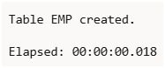
Step 2: Insert Sample Data
INSERT INTO emp VALUES (101, 'Manmeet', 20000, 5000, 3000, NULL);
INSERT INTO emp VALUES (102, 'Aman', 25000, 7000, 4000, NULL);
INSERT INTO emp VALUES (103, 'Simran', 18000, 4000, 2500, NULL);
COMMIT;
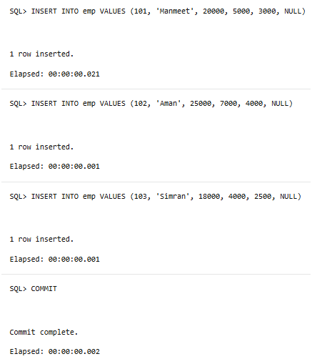
Step 3: Create the Stored Procedure
This procedure will:
- Accept employee number (eno) as input
- Compute total = bp + da + hra
- Update the total column in the table
- Return the computed total to the main block using an OUT parameter
CREATE OR REPLACE PROCEDURE calc_total(
p_eno IN emp.eno%TYPE,
p_total OUT NUMBER
) AS
v_bp emp.bp%TYPE;
v_da emp.da%TYPE;
v_hra emp.hra%TYPE;
BEGIN
-- Fetch employee details
SELECT bp, da, hra
INTO v_bp, v_da, v_hra
FROM emp
WHERE eno = p_eno;
-- Calculate total
p_total := v_bp + v_da + v_hra;
-- Update total column in table
UPDATE emp
SET total = p_total
WHERE eno = p_eno;
COMMIT;
END;
/
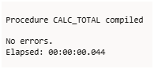
Step 4: Call the Procedure from Main Block
DECLARE
v_total NUMBER;
BEGIN
calc_total(101, v_total);
DBMS_OUTPUT.PUT_LINE('Total Salary of Employee 101 = ' || v_total);
END;
/
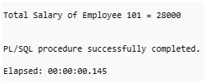
Step 5: Verify the Table
SELECT * FROM emp;
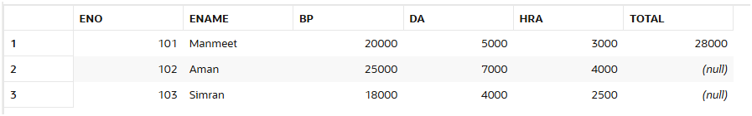
- Write a local function that will accept a number as an input, compute it factorial, and send it to the main block for printing.
Solution:- SET SERVEROUTPUT ON;
DECLARE
-- Declare variables first
num NUMBER := 5;
result NUMBER;
-- Then declare the local function
FUNCTION find_factorial(n NUMBER) RETURN NUMBER IS
fact NUMBER := 1;
i NUMBER;
BEGIN
FOR i IN 1..n LOOP
fact := fact * i;
END LOOP;
RETURN fact;
END find_factorial;
BEGIN
-- Main execution block
result := find_factorial(num);
DBMS_OUTPUT.PUT_LINE('Factorial of ' || num || ' is ' || result);
END;
/
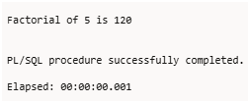
- Write a stored procedure that will accept a number, check whether positive, negative or zero and accordingly print the message.
Solution:- Stored Procedure: check_number_status
SET SERVEROUTPUT ON;

CREATE OR REPLACE PROCEDURE check_number_status (n IN NUMBER) IS
BEGIN
IF n > 0 THEN
DBMS_OUTPUT.PUT_LINE('The number ' || n || ' is Positive.');
ELSIF n < 0 THEN
DBMS_OUTPUT.PUT_LINE('The number ' || n || ' is Negative.');
ELSE
DBMS_OUTPUT.PUT_LINE('The number is Zero.');
END IF;
END;
/
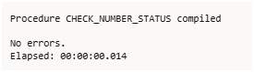
How to Execute It:
BEGIN
check_number_status(10); -- Positive
check_number_status(-5); -- Negative
check_number_status(0); -- Zero
END;
/
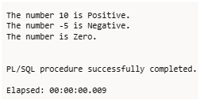
- Write a stored function that will find the sum of elements from 1 to n and send the result to the main block. ‘n’ should send as the input to the called function.
Solution:- Stored Function: find_sum
SET SERVEROUTPUT ON;
CREATE OR REPLACE FUNCTION find_sum(n NUMBER)
RETURN NUMBER
IS
total NUMBER := 0;
BEGIN
FOR i IN 1..n LOOP
total := total + i;
END LOOP;
RETURN total;
END;
/
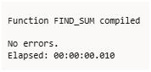
Main Block to Call the Function
DECLARE
num NUMBER := 10;
result NUMBER;
BEGIN
result := find_sum(num);
DBMS_OUTPUT.PUT_LINE('Sum of numbers from 1 to ' || num || ' is: ' || result);
END;
/
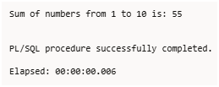
- Write a local procedure that will accept two ranges n1 and n2, find the sum of the average of elements between these ranges and return the result to the main block.
Solution:- CREATE OR REPLACE PROCEDURE sum_of_average(
n1 IN NUMBER,
n2 IN NUMBER,
result OUT NUMBER
) IS
total NUMBER := 0;
cnt NUMBER := 0; -- ✅ changed variable name from count → cnt
avg_val NUMBER := 0;
BEGIN
FOR i IN n1..n2 LOOP
total := total + i;
cnt := cnt + 1;
END LOOP;
avg_val := total / cnt;
result := avg_val;
END;
/
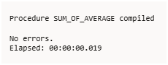
SET SERVEROUTPUT ON;
DECLARE
a NUMBER := 1;
b NUMBER := 5;
res NUMBER;
BEGIN
sum_of_average(a, b, res);
DBMS_OUTPUT.PUT_LINE('The average of numbers from ' || a || ' to ' || b || ' is: ' || res);
END;
/
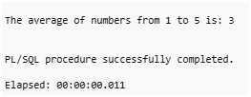
- Write a recursive function to display ‘hello world’ 10 times on the screen. The function should accept the string as input from the main block.
Solution:-
SET SERVEROUTPUT ON;

DECLARE
-- Variable declarations must come first
str VARCHAR2(50) := 'Hello World';

-- Recursive procedure declaration
PROCEDURE display_msg(msg IN VARCHAR2, n IN NUMBER) IS
BEGIN
IF n > 0 THEN
DBMS_OUTPUT.PUT_LINE(msg);
display_msg(msg, n - 1); -- Recursive call
END IF;
END;
BEGIN
-- Call the recursive procedure
display_msg(str, 10);
END;
/
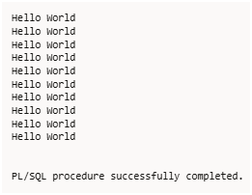
--here are the PL/SQL solutions for Q7–Q10 using the given table structure:
BEGIN
EXECUTE IMMEDIATE 'DROP TABLE student';
EXCEPTION
WHEN OTHERS THEN
IF SQLCODE != -942 THEN -- ignore "table does not exist"
RAISE;
END IF;
END;
/
-- Table creation
CREATE TABLE student (
rollno NUMBER PRIMARY KEY,
name VARCHAR2(30),
sub_id NUMBER,
mark1 NUMBER,
mark2 NUMBER,
mark3 NUMBER
);
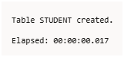
-- Sample data
INSERT INTO student VALUES (1, 'John', 101, 78, 85, 90);
INSERT INTO student VALUES (2, 'Alice', 102, 88, 79, 92);
COMMIT;
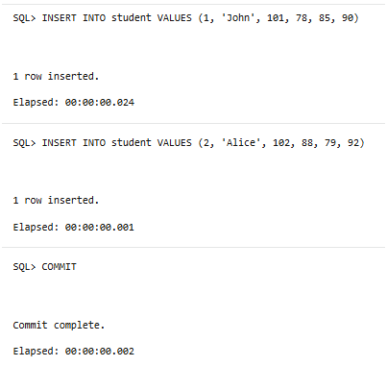
- Write a stored procedure ‘p1’, which will accept the rollno of a student as the input, and then find the sum of the three subject marks and keep it in a variable ‘total’. Send this ‘total’ to the main block of the program and display it.
Solution:- Task: Accept rollno, calculate total of three marks, send to main block.
SET SERVEROUTPUT ON;
CREATE OR REPLACE PROCEDURE p1 (
p_rollno IN student.rollno%TYPE,
p_total OUT NUMBER
) AS
m1 NUMBER;
m2 NUMBER;
m3 NUMBER;
BEGIN
SELECT mark1, mark2, mark3 INTO m1, m2, m3
FROM student
WHERE rollno = p_rollno;
p_total := m1 + m2 + m3;
END;
/
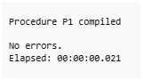
Main block to test:
DECLARE
total NUMBER;
BEGIN
p1(1, total);
DBMS_OUTPUT.PUT_LINE('Total Marks: ' || total);
END;
/
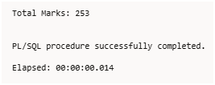
- Write a local function ‘fun2’, which will call the procedure ‘p1’ of Q7 by passing the rollno of a student. It then finds the average of the total marks and stores it in a variable ‘avg’. Send this ‘avg’ to the main block of the program and display it.
Solution:- Task: Call p1, get total, calculate average, return average.
SET SERVEROUTPUT ON;
DECLARE
total NUMBER;
avg_marks NUMBER;
FUNCTION fun2(p_rollno student.rollno%TYPE) RETURN NUMBER IS
t NUMBER;
BEGIN
p1(p_rollno, t);
RETURN (t / 3);
END;
BEGIN
avg_marks := fun2(1);
DBMS_OUTPUT.PUT_LINE('Average Marks: ' || avg_marks);
END;
/
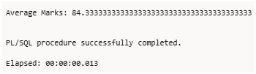
- Write a stored function ‘fun3’ which will accept the rollno of a student as the input and return the highest marks among the three subjects to the main block.
Solution:- Task: Accept rollno, return highest mark among three subjects.
CREATE OR REPLACE FUNCTION fun3(p_rollno student.rollno%TYPE)
RETURN NUMBER IS
m1 NUMBER;
m2 NUMBER;
m3 NUMBER;
highest NUMBER;
BEGIN
SELECT mark1, mark2, mark3 INTO m1, m2, m3
FROM student
WHERE rollno = p_rollno;
highest := GREATEST(m1, m2, m3);
RETURN highest;
END;
/
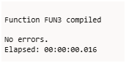
Main block to test:
DECLARE
high NUMBER;
BEGIN
high := fun3(1);
DBMS_OUTPUT.PUT_LINE('Highest Marks: ' || high);
END;
/
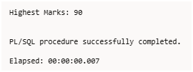
- Write a local procedure p2, which will call the procedure ‘p1’ of Q7 by passing the rollno of a student. It then received the total marks from the procedure ‘p1’ and sent the student’s three subject marks and the total marks to the main block for printing.
Solution:- Task: Call p1, print individual marks and total.
SET SERVEROUTPUT ON;
DECLARE
total NUMBER;
PROCEDURE p2(p_rollno student.rollno%TYPE) IS
m1 NUMBER;
m2 NUMBER;
m3 NUMBER;
t NUMBER;
BEGIN
p1(p_rollno, t);
SELECT mark1, mark2, mark3 INTO m1, m2, m3
FROM student
WHERE rollno = p_rollno;
DBMS_OUTPUT.PUT_LINE('Marks: ' || m1 || ', ' || m2 || ', ' || m3);
DBMS_OUTPUT.PUT_LINE('Total Marks: ' || t);
END;
BEGIN
p2(1);
END;
/
